Increasing the Size of WISE Applets for Classroom Display

For PC users running Windows XP or Windows 2000:

- Right-click on the desktop (do not click on any icon or folder) and select Properties.

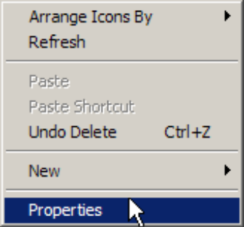

- In the Display Properties window, select the Settings tab.
- Slide the Screen resolution slider to the left to enlarge the appearance of the applet.
800x600 or less may work well for the WISE applets, depending on your monitor.

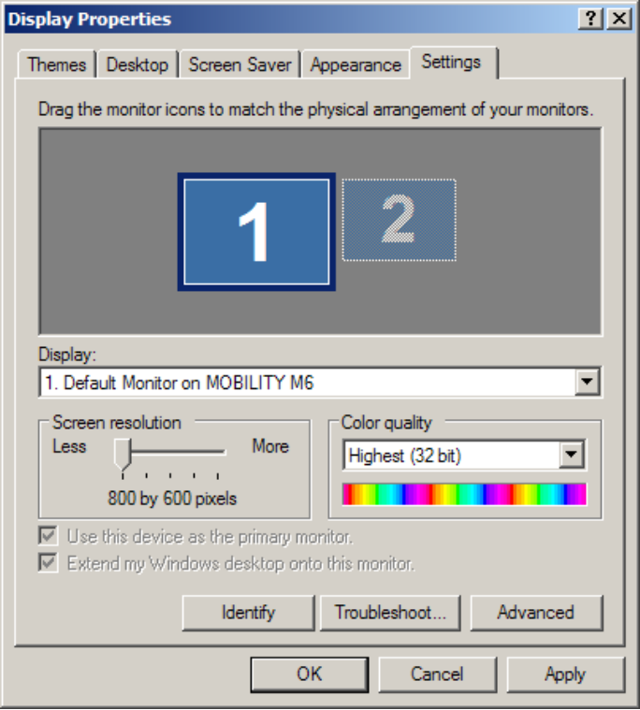

- Click Apply.
- If prompted to confirm the changes, click Yes.
- Click OK.
For Mac OS X users:

- Select System Preferences from the Apple menu or from the system toolbar.
- Under Hardware, click on the Displays icon.

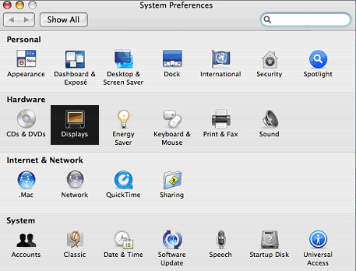

- Locate the Resolutions box and scroll up to the desired setting.

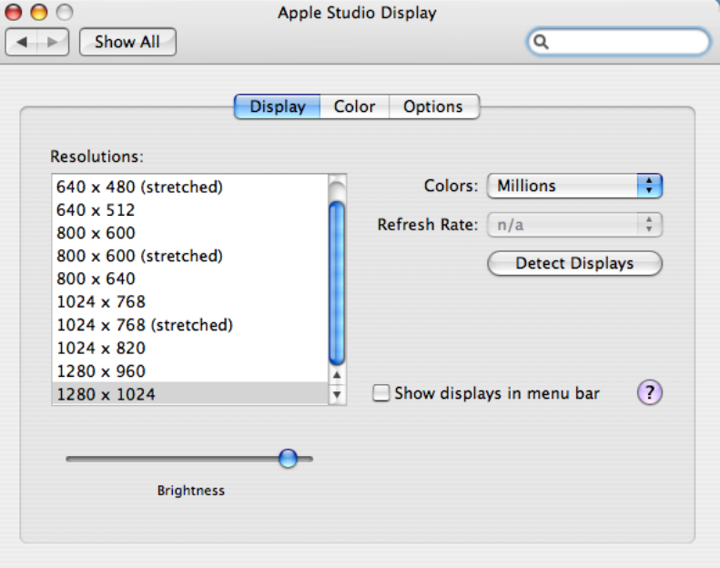

- If you encounter a new window titled, “About to change the display mode…” Click OK.

